Revision on outcome2

Artificial Intelligence (AI): Artificial intelligence is the ability of machines to perform tasks that normally require human intelligence, such as speech recognition, natural language understanding, and decision-making..
Machine Learning: Machine learning is a branch of artificial intelligence that involves training machines to learn from data without being explicitly programmed. It also allows computer systems to improve their performance in a particular task over time by learning from examples.
Deep Learning: Deep learning is a type of machine learning that uses an artificial neural network to reach accurate conclusions without human intervention.
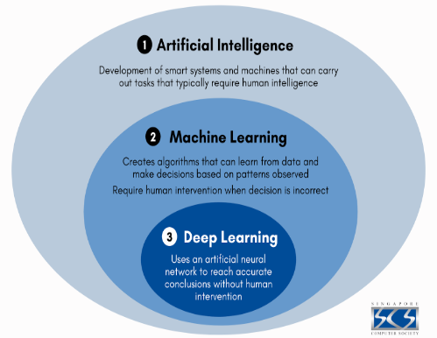
Types of machine learning:
1-Supervised Learning: In this type, the algorithm is trained on a labeled dataset. The target variable is known and the goal is to predict the target variable for new data.
For example, a facial recognition algorithm can be trained on a dataset of images containing human faces marked by people's names.
.
2-Non-Supervised Learning: In this type, the algorithm is trained on an unclassified dataset. The target variable is unknown and the goal is to find patterns and structure in the data..
3-Semi- Supervised Learning
This is a combination of supervised and unsupervised learning, where the algorithm is trained on a partially labeled dataset, and the goal is to predict the target variable for the remaining unlabeled data.
4- Reinforcement learning:
In this genre, the algorithm learns through trial and error. The algorithm interacts with an environment and receives rewards or penalties based on its actions.
For example, a robot can be trained to learn how to walk by trial and error, receiving a reward when it can walk a longer distance without falling.
There are two fundamental types of supervised machine learning tasks:
1. Classification: the algorithm tries to predict which category the data point belongs to. The output is a categorical variable or binary value.
.2Regression: The algorithm tries to predict a numerical value from features.
Algorithms used in regression:
1-Linear Regression
2-Polynomial Regression
3-Decision Tree Regression
4-Random Forest Regression
Algorithms used in classification:
1- Logistic Regression
2-Decision Tree Classification
3- K-Nearest Neighbor Classification
4-Support Vector Machine Classification
Algorithms for both regression and classification:
1-Support Vector Regression
2-Tree-based algorithms
3-Naive Bayes
Model: It is a set of rules that represents data and can be used to make predictions.
Features: It’s property or characteristic of the data that the model can use to make predictions.
Note: Any Column or data in the model is considered a feature.
The machine learning life cycle:
1-Gathering Data: Collecting data that will be used to train the model

2-Data Preparation: It involves preparing the data before training the model on it.

3-Analyze Data: Trying to extract some useful insights from the data that may help us in the training process.

4-Train the Model: It involves give the model data and extract formulas from it until it can work on the new data.

5-Test the Model: The model must be tested to ensure that it performs well on unseen data.

6-Deployment: In this stage, the model is given a suitable user interface that the normal user can deal with whether on smartphones or PCs.
Feature engineering: Feature engineering is the process of selecting, extracting, and transforming features from raw data
The importance of feature engineering:
1-Improve the quality of the data
2-Reduce the complexity of the machine learning model
3- Improve the accuracy of the model
4-Reduce overfitting
Some of the most common topics in feature engineering include:
1-Feature selection: That involves choosing the important features
2-Feature extraction: Transforming row data into a set of meaningful features
3-Feature scaling: Normalizing the data to improve the performance of the model
4-Feature encoding: Converting data into numerical values
5-Feature transformation: Applying mathematical function to the features to improve their quality.
Some of the most common algorithms used in feature engineering include:
1- Principal Component Analysis (PCA)
2- Recursive Feature Elimination (RFE)
3- t-Distributed Stochastic Neighbor Embedding (t-SNE)
4- One Hot Encoding
Sample variance: is a measure of how prevalent data is around its average. Used to measure how different the values in the dataset are from each other.
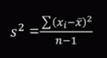
S²=sample variance
∑ = sum of
X_{i} = data point
X⁻ = mean of the data set
N = number of data point
The Population Variance:
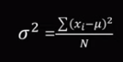
σ² = population variance
∑ = sum of
X_{i} = data point
μ = mean of the data set
N = number of data point

Standard Deviation: Standard Deviation is the square root of the Population Variance.
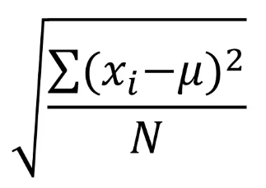
√ = Square root
∑ = sum of
X_{i} = data point
μ = mean of the data set
N = number of data point

Skewness: Is a measure of how consistent the distribution of data is
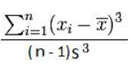
∑ = sum of
X_{i} = data point
X⁻ = mean of the data set
N = number of data point
S = Standard Deviation

4-Quartiles: https://youtu.be/4L5J49T0He4?si=4kgN4A9Gmf78apw1
Data Exploration and Preparation Procedures:
1- Variable Identification: That involves identifying and understands all variables in data
2- Uni-variate Analysis: Each variable is defined and understood and investigated individually.
Box plot: Is used to visualize the descriptive statistics of a variable. It is used to detect outliers
Histogram: It's used to show the distribution between the distinct values of some column values and the count of the repetitions for each value.
3-Bi-variate Analysis: It's used to Identifies the relationship between two variables.
Combinations include:
1-Categorical and categorical
2-Categorical and Continuous
3- Continuous and Continuous
Scatter plot: It's used to show the relationship between two variables
Correlation: It's used to determine the strength between two variables
4-Missing value treatment:
1-Delete/Drop the missing value: If the data is little or there are strong relationships between the data, this method is not good
2-Mean/Mode/Median imputation: that involves fill the NAN values with mean or mode or median for column
3-Predection model: predictive model is developed to predict values to fill NAN values

5-Encoding categorical data: Is the process of converting data from format to another format.
There are different types of encoding used in computing such as:
1-character encoding: Is the process of converting set of characters into digital form
2-Audio encoding: Is the process of converting analog data into digital form
3-video encoding: Is the process of converting analog data into digital form
Why data encoding is necessary?
1-Compatibility: Encoding allows convert data into another format to compatible with device.
2-Efficency: Encoding can compress data file to provide space.
3-security: Encoding can encrypt data to adding security
4-Error detection and correction: Some encoding includes error detection and correction.
Some of the most commonly used types of encoding:
1-One-hot encoding: It is a technique used to represent categorical variables as binary vectors.
This technique is widely used for nominal categorical variables.
Each value is represented as a vector where 1 is at the position corresponding to the value and the other is 0.
2-Ordinal encoding: It assigns a unique integer value to each category based on its order or rank.
This technique suitable for ordinal categorical variables.
3-Label encoding: It assigns a unique integer value to each category without any relation order or rank.
This technique is commonly for nominal categorical variables.
4-Binary encoding: representing a binary value to each column.
5-Count encoding: it replaces each category with the number of times it appears in the data set.
6-Target encoding: It replaces each category with a sum the target variable divide on number of category.

There are two types of categorical variable:
1-Ordinal variable: These are variables that accept the natural ordering of categories
2-Nominal variables: These are variables that don’t accept the natural ordering of categories.

6-Outlier Treatment:
1-Removal of outlier: That involves remove outlier from data set.
2-Winsorization: Determine the limits of winsorization:
Two percentiles are defined as thresholds to identify outliers.
For example, 5% and 95% can be specified as winsorization limits.
Replace outliers:
All values ​​outside the winsorization bounds are replaced by the value at the closest bound.
For example, if 100 is the maximum value at 95%, any value greater than 100 will be replaced with 100.
3-transformation: That involves applying a mathematical function to the data to reduce the impact of outlier.
4-Binning: This involves dividing the data into groups and calculating the mean for each group, and any number that falls between the group numbers is replaced for the mean.
5-Machine learning techniques: there is some machine learning techniques used to identifying and remove the outliers.

7-Feature scaling: Normalization and standardization are two method of feature scaling.
Why do we use scaling?
1- Avoid dominance of properties with larger values.
2- Improving the accuracy of machine learning algorithms.
3- Speed ​​up the training process.
4- Convert large numbers to smaller values.

